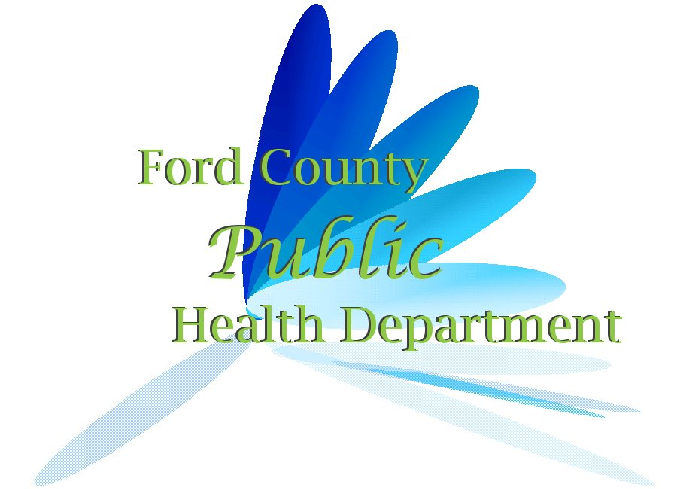
Ford County Board of Health Meeting
Gibson Area Hospital West Boardroom
April 18, 2023, 6:00 p.m.
Agenda:
- Call to Order
- Roll Call
- Approve Payment of Current Bills
- Approve Minutes of the Previous Meeting
- Finance Report
- Visitors
- Administrator’s Report
- Old Business
  - Environmental Health Fees--correction
- New Business
  - Reappointment
  - Election of Officers
  - Equipment Donation
  - Health Insurance
- Closed Session
  - Pursuant to 5 ILCS 120/2(c)(1) - Personnel Reasons
- Other
- Adjourn
Next regularly scheduled meeting date is July 18, 2023

